Name: Sagar Singh  
Id: 22000272

Prompt Engineering by Husain Ali

Classroom Image generation

Prompt:

Create a detailed image of a modern computer lab with the following features: A spacious room with white-painted walls. 30 desktop computers placed on desks, with 20 students actively working on them. A large whiteboard at the front of the room. A ceiling-mounted projector projecting a computer image onto the wall opposite the viewer's perspective. Six ceiling fans evenly distributed across the ceiling. Two air conditioners are mounted on the walls for ventilation. The students are seated at their desks, focused on their computers, creating a professional and educational atmosphere. The lab should feel organized, well-lit, and conducive to learning."  
Image:

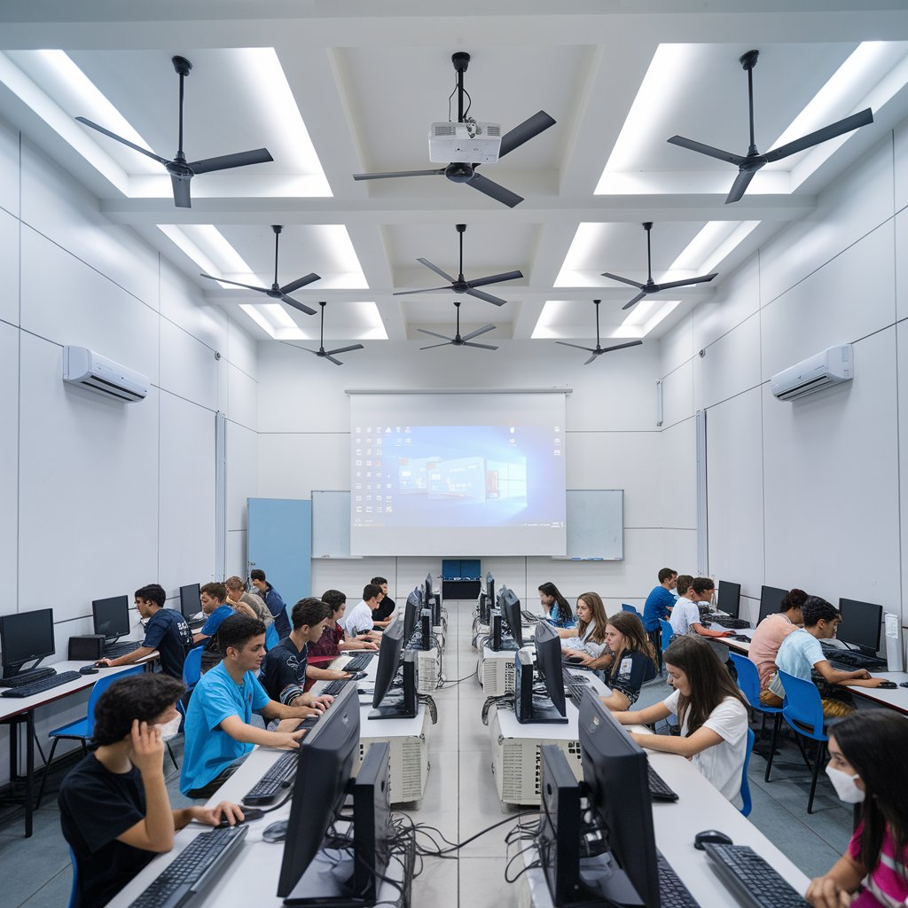

Bank robbery prompt:

Depict a dramatic scene of a bank robbery in progress. The setting is a modern bank with counters, a vault door visible in the background, and scattered papers and money. Four robbers dressed in dark clothing with black masks over their faces are holding guns and carrying large bags. Several frightened hostages, including employees and customers, are sitting on the floor with their hands raised or tied. The atmosphere is tense, with a sense of urgency and danger. The robbers are positioned strategically, some near the hostages and others watching the entrance, emphasizing the chaos and high-stakes drama of the scene."

Image:

